What is the Summer Food Service Program?

The U.S. Department of Agriculture (USDA) provides reimbursement to eligible sponsors supporting summer programs that serve children in low-income areas when school is not in session. These benefits are available through the California Department of Education (CDE), Summer Food Service Program (SFSP).

The money sponsors receive from the USDA allows them to devote a smaller portion of resources to food-related expenses, freeing up funds that can be used for other activities.

The USDA reimburses programs for serving:

- Meals to children in low-income areas during summer months
- Snacks to children in low-income areas after school

With the SFSP, children get the nutrition they need to learn, grow, and play when they return to school.

Who is eligible to become a sponsor?

The following entities may be approved to sponsor the SFSP:

- Public or private nonprofit schools
- Public or private nonprofit residential camps
- Local county, state, federal government entities
- Public or private nonprofits located on college campuses such as Upward Bound Programs, Summer Bridges, or National Youth Sports Programs
- Private nonprofits such as food banks, boys and girls clubs, churches, etc.

Where do children go for summer meals?

Many agencies below already have children attending educational, enrichment, and recreational activities, which can be an SFSP meal service site. Nutritious meals can be served at these locations and others:

Head Start Centers Schools
Community Action Agencies Hospitals
Boys and Girls Clubs Kids’ Cafes
21 Century Learning Libraries
Programs at Colleges Food Banks
Park and Recreational Centers 4H Clubs
National Youth Sports Salvation Army
Vacation Bible schools YMCAs
Homeless Shelters Camps

How can organizations participate?

There are two ways an agency may help provide meals to children:

- Become a sponsor and establish meal sites in low-income areas

- Become a site and receive, serve, and report meals served to the sponsoring agency

Some organizations may not be able to sponsor the program because their staff, time, and resources are limited. These agencies may still participate by becoming a SFSP site. Sites will have an arrangement with the SFSP sponsor they select to administer the program.

Agencies may obtain a list of sponsors by county from our summer meal services sites Web page at
http://www.cde.ca.gov/ds/sh/sn/summersites.asp
Each sponsor must determine if the site is eligible, train staff, arrange for meals to be prepared or delivered, monitor the site, and prepare claims for reimbursement.

Operators of summer food service sites will:

- Attend their sponsor’s training
- Supervise activities and meal services
- Distribute meals
- Track the number of meals served
- Store food appropriately
- Keep the site clean and sanitary
- Follow SFSP guidelines

What kind of meals must be served?

All meals and snacks must meet the USDA’s nutrition standards. Most meal service sites can provide up to two meals – breakfast and lunch, breakfast and supper, or one meal and a snack.

Below are a few ideas of what food items agencies can serve.

SAMPLE MENUS

Breakfast | Lunch or Supper | Snack
Chocolate milk  Raisin toast Apple sauce | Milk  Bean burrito  Carrot sticks  Pineapple chunks | Milk  Blueberry muffin
Milk  Cereal  Orange juice | Chocolate milk  Grilled chicken sandwich  Lettuce  Peaches | Yogurt  Banana
Milk  Bagel  Peaches | Milk  Ham and cheese  sandwich  Carrot sticks  Apple | 100% Apple juice  Graham Crackers

Who should you contact first?

Please contact a CDE SFSP staff member by phone at 800-952-5609 option 6 or by e-mail at sfsp@cde.ca.gov. Staff will answer your questions and help you get started.

Want more information?

Visit our Web page for more information:
http://www.cde.ca.gov/ls/nu/sf/sfspinfo.asp

The CDE’s Summer Food Crew:

Melissa Garza
916-322-5885 or mgarza@cde.ca.gov

Dennis Arena
916-324-9073 or darena@cde.ca.gov

Tanya Mc Crae
916-322-8323 or tmccrae@cde.ca.gov

Augie Aguilar
916-327-5865 or auaguilar@cde.ca.gov

*Diane Gilmore
916-445-7360 or dgilmore@cde.ca.gov

*Ron Reid
916-322-5113 or roreid@cde.ca.gov

* Available part-time August through March.

USDA is an equal opportunity provider and employer.

Help feed hungry children with USDA’s

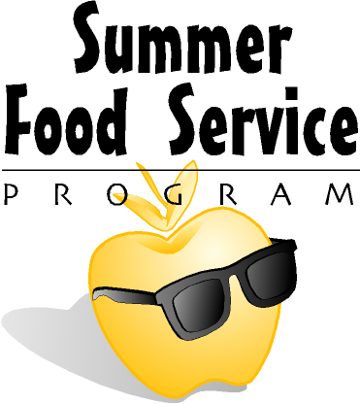

Become a Summer Food Sponsor

Children need nutritious meals all year long, even when they are not in school. The Summer Food Service Program provides healthy meals to children and teens ages eighteen and younger, free of charge.

California Department of Education
Summer Food Service Program
November 2012

