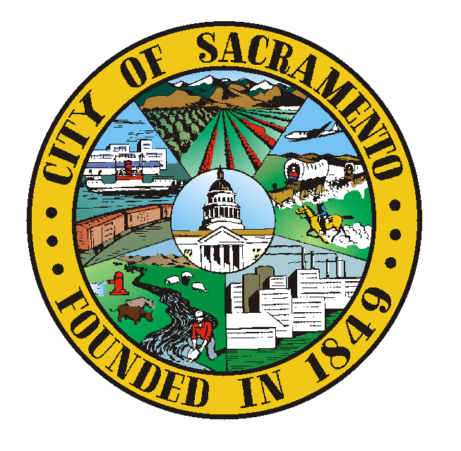 SUMMER AT CITY HALL
EVALUATION

To make this program the best it can be, please complete the below evaluation by circling the response that best describes how you felt about each item.

1. How useful has the program been overall in helping you learn about what Public Service means and how City Government operates?

a) Very useful b) Useful c) Somewhat Useful d) Not Useful

2. How useful has the program been overall in helping you build skills to help you with your internship?
a) Very useful b) Useful c) Somewhat Useful d) Not Useful

2. How interesting has the program been overall ?
a)Very interesting b) Interesting c) Somewhat Interesting d) Not Interesting

3. Please rate the first hour check-in and learning activities on how useful and how interesting they have been:
a) Very useful b) Useful c) Somewhat Useful d) Not Useful
a)Very interesting b) Interesting c) Somewhat Interesting d) Not Interesting

What would improve this part of the program for you? Please write comments:

4. Please rate how useful and how interesting the various guest speakers/Field Trips have been
i. Stand Up, Mayors Education Initiative
a) Very useful b) Useful c) Somewhat Useful d) Not Useful
a)Very interesting b) Interesting c) Somewhat Interesting d) Not Interesting

ii. Crocker Art Museum Tour
a) Very useful b) Useful c) Somewhat Useful d) Not Useful
a)Very interesting b) Interesting c) Somewhat Interesting d) Not Interesting

iii. 24th street Corp Yard and 311 visit
a) Very useful b) Useful c) Somewhat Useful d) Not Useful
a)Very interesting b) Interesting c) Somewhat Interesting d) Not Interesting

iii. Homeless Overview/presentation
a) Very useful b) Useful c) Somewhat Useful d) Not Useful
a)Very interesting b) Interesting c) Somewhat Interesting d) Not Interesting

iv. Loaves and Fishes field trip
a) Very useful b) Useful c) Somewhat Useful d) Not Useful
a)Very interesting b) Interesting c) Somewhat Interesting d) Not Interesting

iv. Community leaders who came to help you work on your projects
a) Very useful b) Useful c) Somewhat Useful d) Not Useful
a)Very interesting b) Interesting c) Somewhat Interesting d) Not Interesting

v. Weekend service projects, if you attended them
a) Very useful b) Useful c) Somewhat Useful d) Not Useful
a)Very interesting b) Interesting c) Somewhat Interesting d) Not Interesting

Comments( positive or changes you would like to see in the speakers or field trip part of the program)

5. Please rate the group project you did around a community issue:
a) Very useful b) Useful c) Somewhat Useful d) Not Useful
a)Very interesting b) Interesting c) Somewhat Interesting d) Not Interesting

What was interesting or useful about this group project?

What would improve this part of the program for you?

6. Please tell us three things you learned from the class

7. Give us feedback on your internship
a. Overall my internship experience was
a) excellent b) very good c) good d) not very good
a)Very interesting b) Interesting c) Somewhat Interesting d) Not Interesting
b) What did you most like about your internship

c) What would you have changed about your internship

d) What were three things you learned during your internship about the city, yourself, the place you worked, or about working with others

e. Do you feel you improved your work related skills as a result of the program
Very Definitely _____ Definitely_____ Somewhat ______ Not really____

As a result of this experience, are you more likely to volunteer in your community?
Yes___ No____ I already volunteer a lot_____

As a result of the class do you believe you have increased your knowledge of how city government works?
Very Definitely _____ Definitely_____ Somewhat ______ Not really____

As a result of this class, do you believe you have the power to make change in the community
Very Definitely _____ Definitely_____ Somewhat ______ Not really____

As a result of this class, do you feel you know who to call at the city if you have a problem in your community
Very Definitely _____ Definitely_____ Somewhat ______ Not really____

As a result of this class, do you know better how to advocate for changes you want to see
Very Definitely _____ Definitely_____ Somewhat ______ Not really____

As a result of this class, how many more adults do you feel you now know well enough that you could call them for help or advise on your career or your life? 0___ 1-3____4-5___ more than 6

Concepts and Terms
Please match the column a terms/concepts with definitions from Column B
 | Column A | Answer | Column B
1 | advocacy |  | a.The body that decides what graduation requirements students have to abide by
2. | Policy |  | b.Jay Schenirer
3. | City Council |  | c.Number of city council members
4. | City Manager |  | d.Speaking up for what you believe in
5. | School Board |  | e.Recouping the actual Cost of services from the public
6. | The Mayor |  | f.Avoidance, Confront, ????
7. | The name of one city Council member |  | g.The body that allocates funds for city parks
8. | Grants |  | h.Crocker art museum, as an example
9. | Fee for Service |  | i.Creating links between people
10 | Public private partnership |  | j.Laws or rules of an organization or community that governs how people behave or what is legal
11 | Networking |  | k.The person who runs the daily city operations
12 | Ways people deal with conflict |  | l.Money that does not have to be paid back, but has strings attached
13 | Eight |  | M. Kevin Johnson
 | List three ways you can influence/change a community concern you may have |  | a.
 | Write down 5 city departments or functions you learned about over the summer |  | a.  b.  c.  d.  e.  f  g.
 | List three current city concerns or issues that the city council is addressing |  | A  B  C

