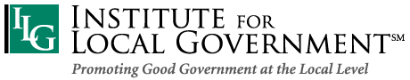

Governments Engaging Youth
ILG seeks to raise local leaders’ awareness of the importance of youth civic engagement as well as to identify and spotlight municipal efforts in California. We aim to offer technical assistance to support the growing interest and ability of municipal governments to authentically engage the next generation of active citizens and future public service workers.

Vision
Partners & More
- Sacramento County Office of Education
- Linked Learning Alliance
- Council for a Strong America
- Endorsed by:
- City Managers Department of the League of California Cities
- California Chapter of the International City/County Managers Association (Cal-ICMA)
Communities and schools collaborate to prepare students for civic life and college/career readiness.

Mission
Create strong partnerships between school districts and local government entities to offer students opportunities to gain 21st century work skills; build interest in public service careers; provide tools to become civically aware and engaged; and bring authentic youth voices to local government issues.

Need
The success of our nation and state depends on educated, informed and active citizens and residents. However, we are not preparing our diverse residents with the civic knowledge, skills and values they need to succeed in college, career and civic life. A few sobering facts tell the story. The United States recently ranked 139th in voter participation of 172 democracies around the world. Less than half of eligible young people ages 18-24 are registered to vote in California and less than 8% actually voted in the 2014 primary election. In California, less than 50 percent of high school seniors surveyed viewed being actively involved in state and local issues as their responsibility. Furthermore, local governments will be facing hiring needs in the future as baby boomers retire and, the diversity of that workforce needs to better match the make- up of its citizens.

We have much to gain by revitalizing civic learning. The chief benefits of civic learning are a vibrant and informed civic life and democracy and a healthy society. High-quality civic learning also helps teach children skills they need for the 21st century workplace, such as critical thinking, problem solving, communication, collaboration, creativity, initiative and innovation. Exposing youth to municipal governments early will hopefully prepare a more informed and engaged citizenry as they grow up, but also help entice a more diverse group of young people to consider careers in public service.
For more information:
Visit: www.ca-ilg.org/GovernmentsEngagingYouth
Martin Gonzalez, Director, Institute for Local Government: mgonzalez@ca-ilg.org
Bina Lefkovitz, Lead Consultant: blefkovitz@gmail.com

Examples of Governments Engaging Youth:
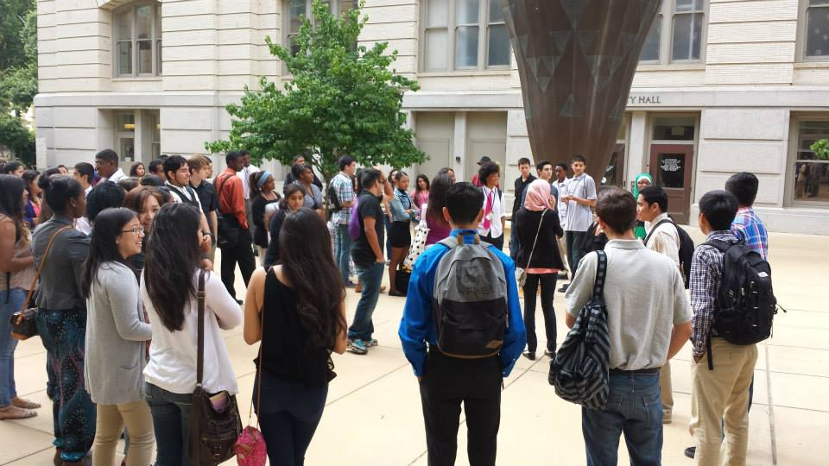
Sacramento Summer at City Hall
Created in 2010, Sacramento Summer at City Hall (SACH), currently offers 100 high school students a six week summer program at city hall to learn about local government, careers in local government and how to advocate for community change. Students attend classes in the mornings at city hall and internships in the afternoons. The classes include guest speakers from the city on what local government does and how the city operates, attendance at a city council meeting, field trips to city facilities, a day on voter registration and a simulated election, financial literacy, job readiness skill development. Students also present advocacy projects they develop over the summer to a panel of city council members and community leaders. The project is funded by a partnership among the City of Sacramento, Way Up Sacramento and Sacramento City Unified School District. During the school year a one day site visit to city hall hosts 60 11th graders to learn about local government and present advocacy projects developed during school to a panel of city council members. For more information, see:
SACH participants gather outside of Sacramento’s City Hall for a tour and training with city staff.
www.cityofsacramento.org/ParksandRec/Neighborhood-Services/Programs/Summer-at-City-Hall

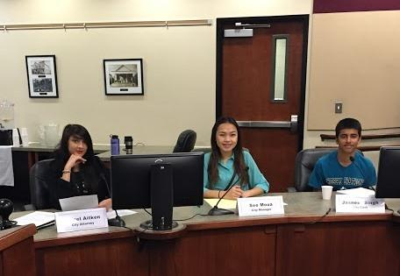
Strides Towards Entering Public Service (STEPS)
West Sacramento has adapted SACH and provides internships to both high school and college level students to expose them to careers in local government. For more information see: www.cityofwestsacramento.org/civica/filebank/blobdload.asp?BlobID=11807

Youth in Government, City of Davis
This program provides a three day experience to 30 high school students who job shadow local officials, study several city issues and then debate and vote on the issues in a student run mock city council meeting.

Elk Grove Summer at City Hall
The City of Elk Grove and EGUSD, offer a two week SACH program that includes classroom learning at city hall, plus afternoons of job shadows and a student run mock city council meeting where students present ideas on a real city issue studied over the course of the two week class.
During a mock council meeting Elk Grove students served as city staff members and carried out duties and roles of the city manager, city clerk and city attorney.

Governments Engaging Youth Overall Program Objectives & Benefits
Students:
- Learn how local governments (city, county, special districts, joint power agencies) operate, their structure, function, roles, current issues and politics;
- Develop interest to become more civically involved in making their community a better place to live, work and play;
- Learn what it means to be an active citizen: voting, volunteering, advocating, leading and fundraising (philanthropy);
- Learn about the election process, election issues and how to vote;
- Advocate for a change in their neighborhoods, learn the steps and skills needed to do advocacy and reflect on how they can use advocacy skills in their daily lives;
- Find volunteer opportunities in the community, potentially complete a service project and reflect on its impact on themselves and their community; and / or
- Explore and experience careers in municipal government and gain work experiences that inform college and career choices.
Local Governments:
- Connect with youth in the community and better understand the community through the lens of youth and strengthen intergenerational relationships;
- Enhance awareness of youth focused concerns and impacts of municipal policies and practices on youth;
- Strengthen supervisory skills of staff managing interns and develop human resource skills in leading the next generation of workers;
- Create pipelines for future workforce that better reflects the diversity of the community;
- Expand the pool of the next generation of civic leaders and activists; and / or
- Build stronger relationships between local governments and schools (and districts).

Flexible Program Design
The timing, duration and intensity of Governments Engaging Youth (GEY) programs depends on the municipal government’s capacity, and what works best for that jurisdiction. GEY can be a one day field trip to the municipal entity, a six week summer program or offered as a school year after school program format.

To date, GEY has been accomplished through the leadership of both the cities and school districts; but it can also be accomplished independently by cities, special districts or counties. A joint effort is preferred as it helps leverage funds and expertise from both entities. The schools bring expertise in teaching students about civics and 21st century skills, they also have access to students for program recruitment; and the local agencies bring expertise around the ins and outs of how government operates, access to internships or job shadows, and how to address local issues that impact our youth. The project encourages municipal entities, school districts, private and non-profit agencies to partner together so that students experience the collaboration needed among entities to solve community issues and concerns.

