Redwood Empire Food Bank Grows Healthy Habits

with Power Play
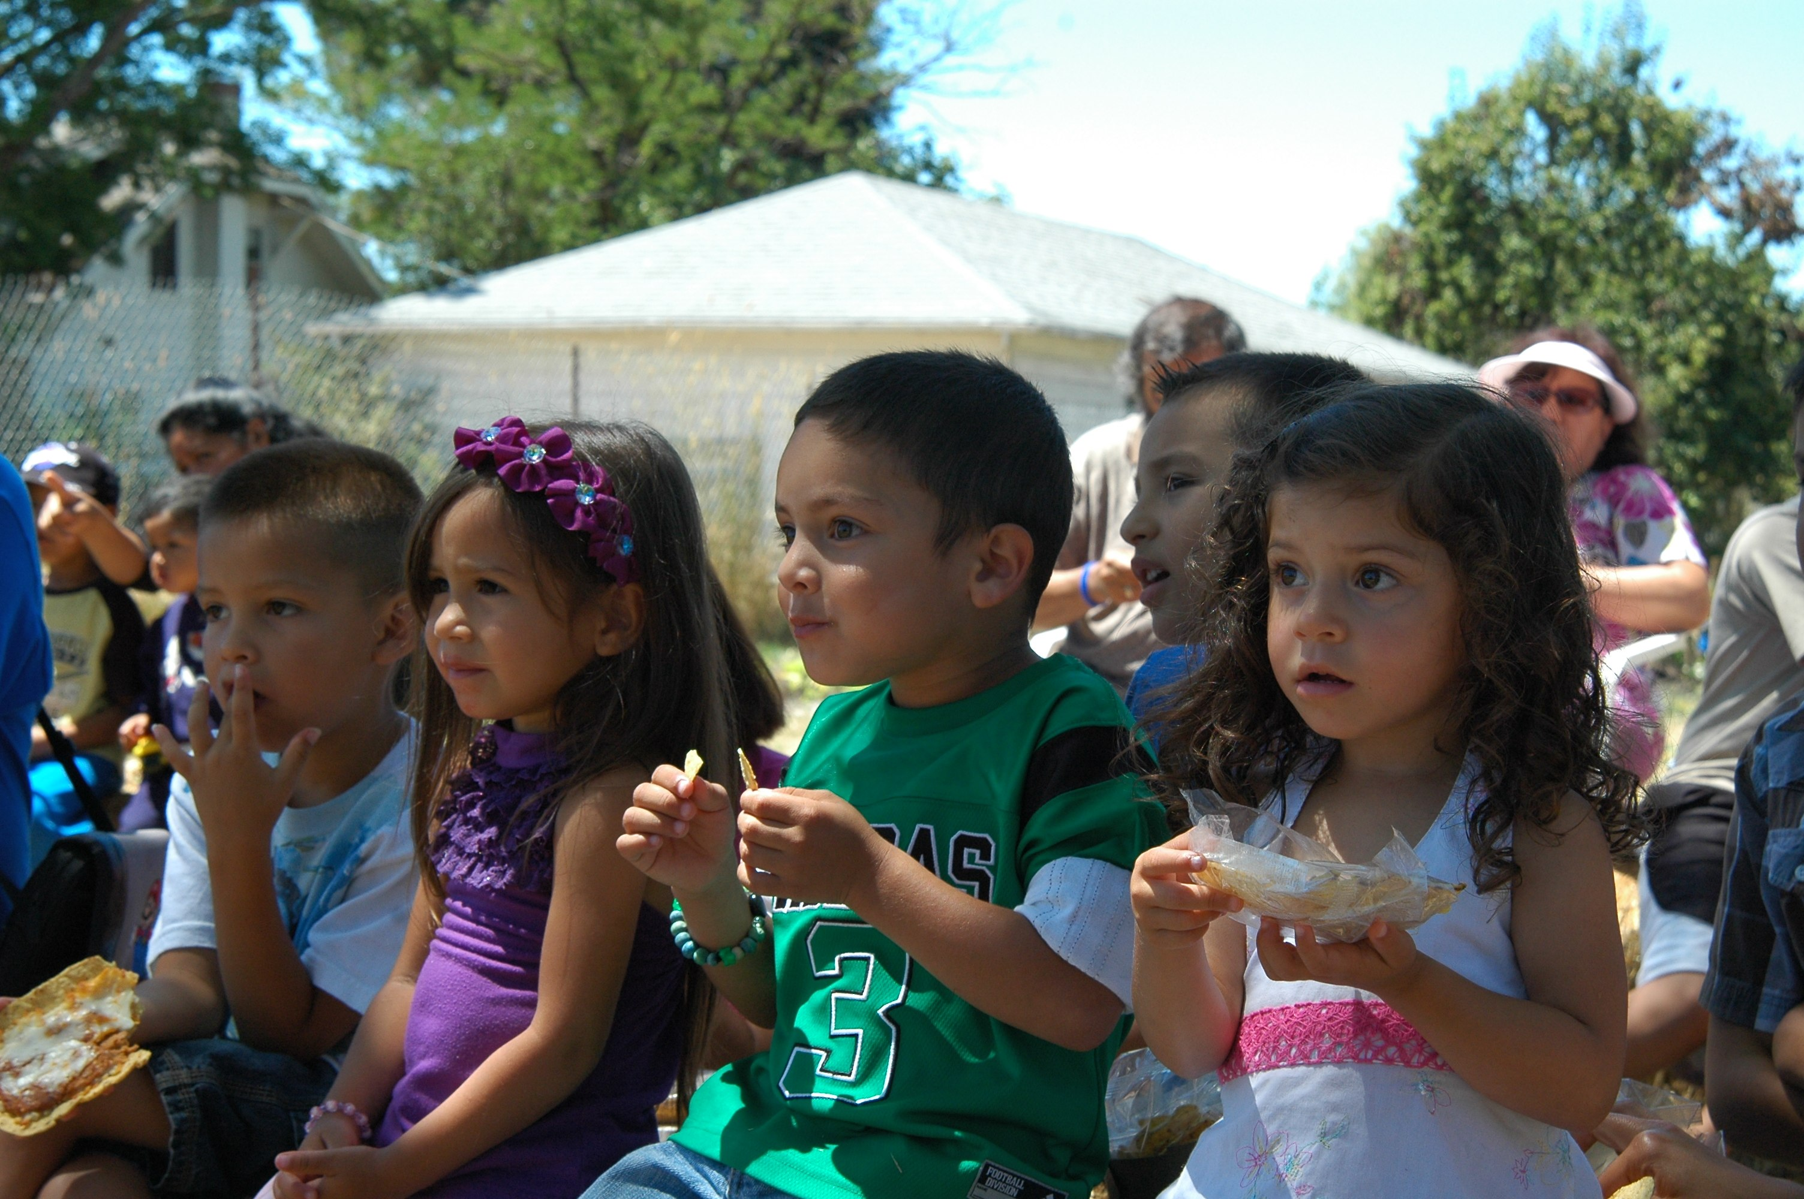

Great ideas are growing at Redwood Empire Food Bank (REFB) this summer. To keep kids active and engaged in learning healthy habits, REFB developed a creative, garden-based nutrition education curriculum.

Kids at 16 of REFB’s summer sites participated in gardening activities such as planting lettuce in pots and sprouting beans. As many as 600 kids participated in REFB’s four gardening rodeos at local Boys & Girls Clubs where they had the opportunity to participate in favorite activities like bug identification and making scissor salsa.

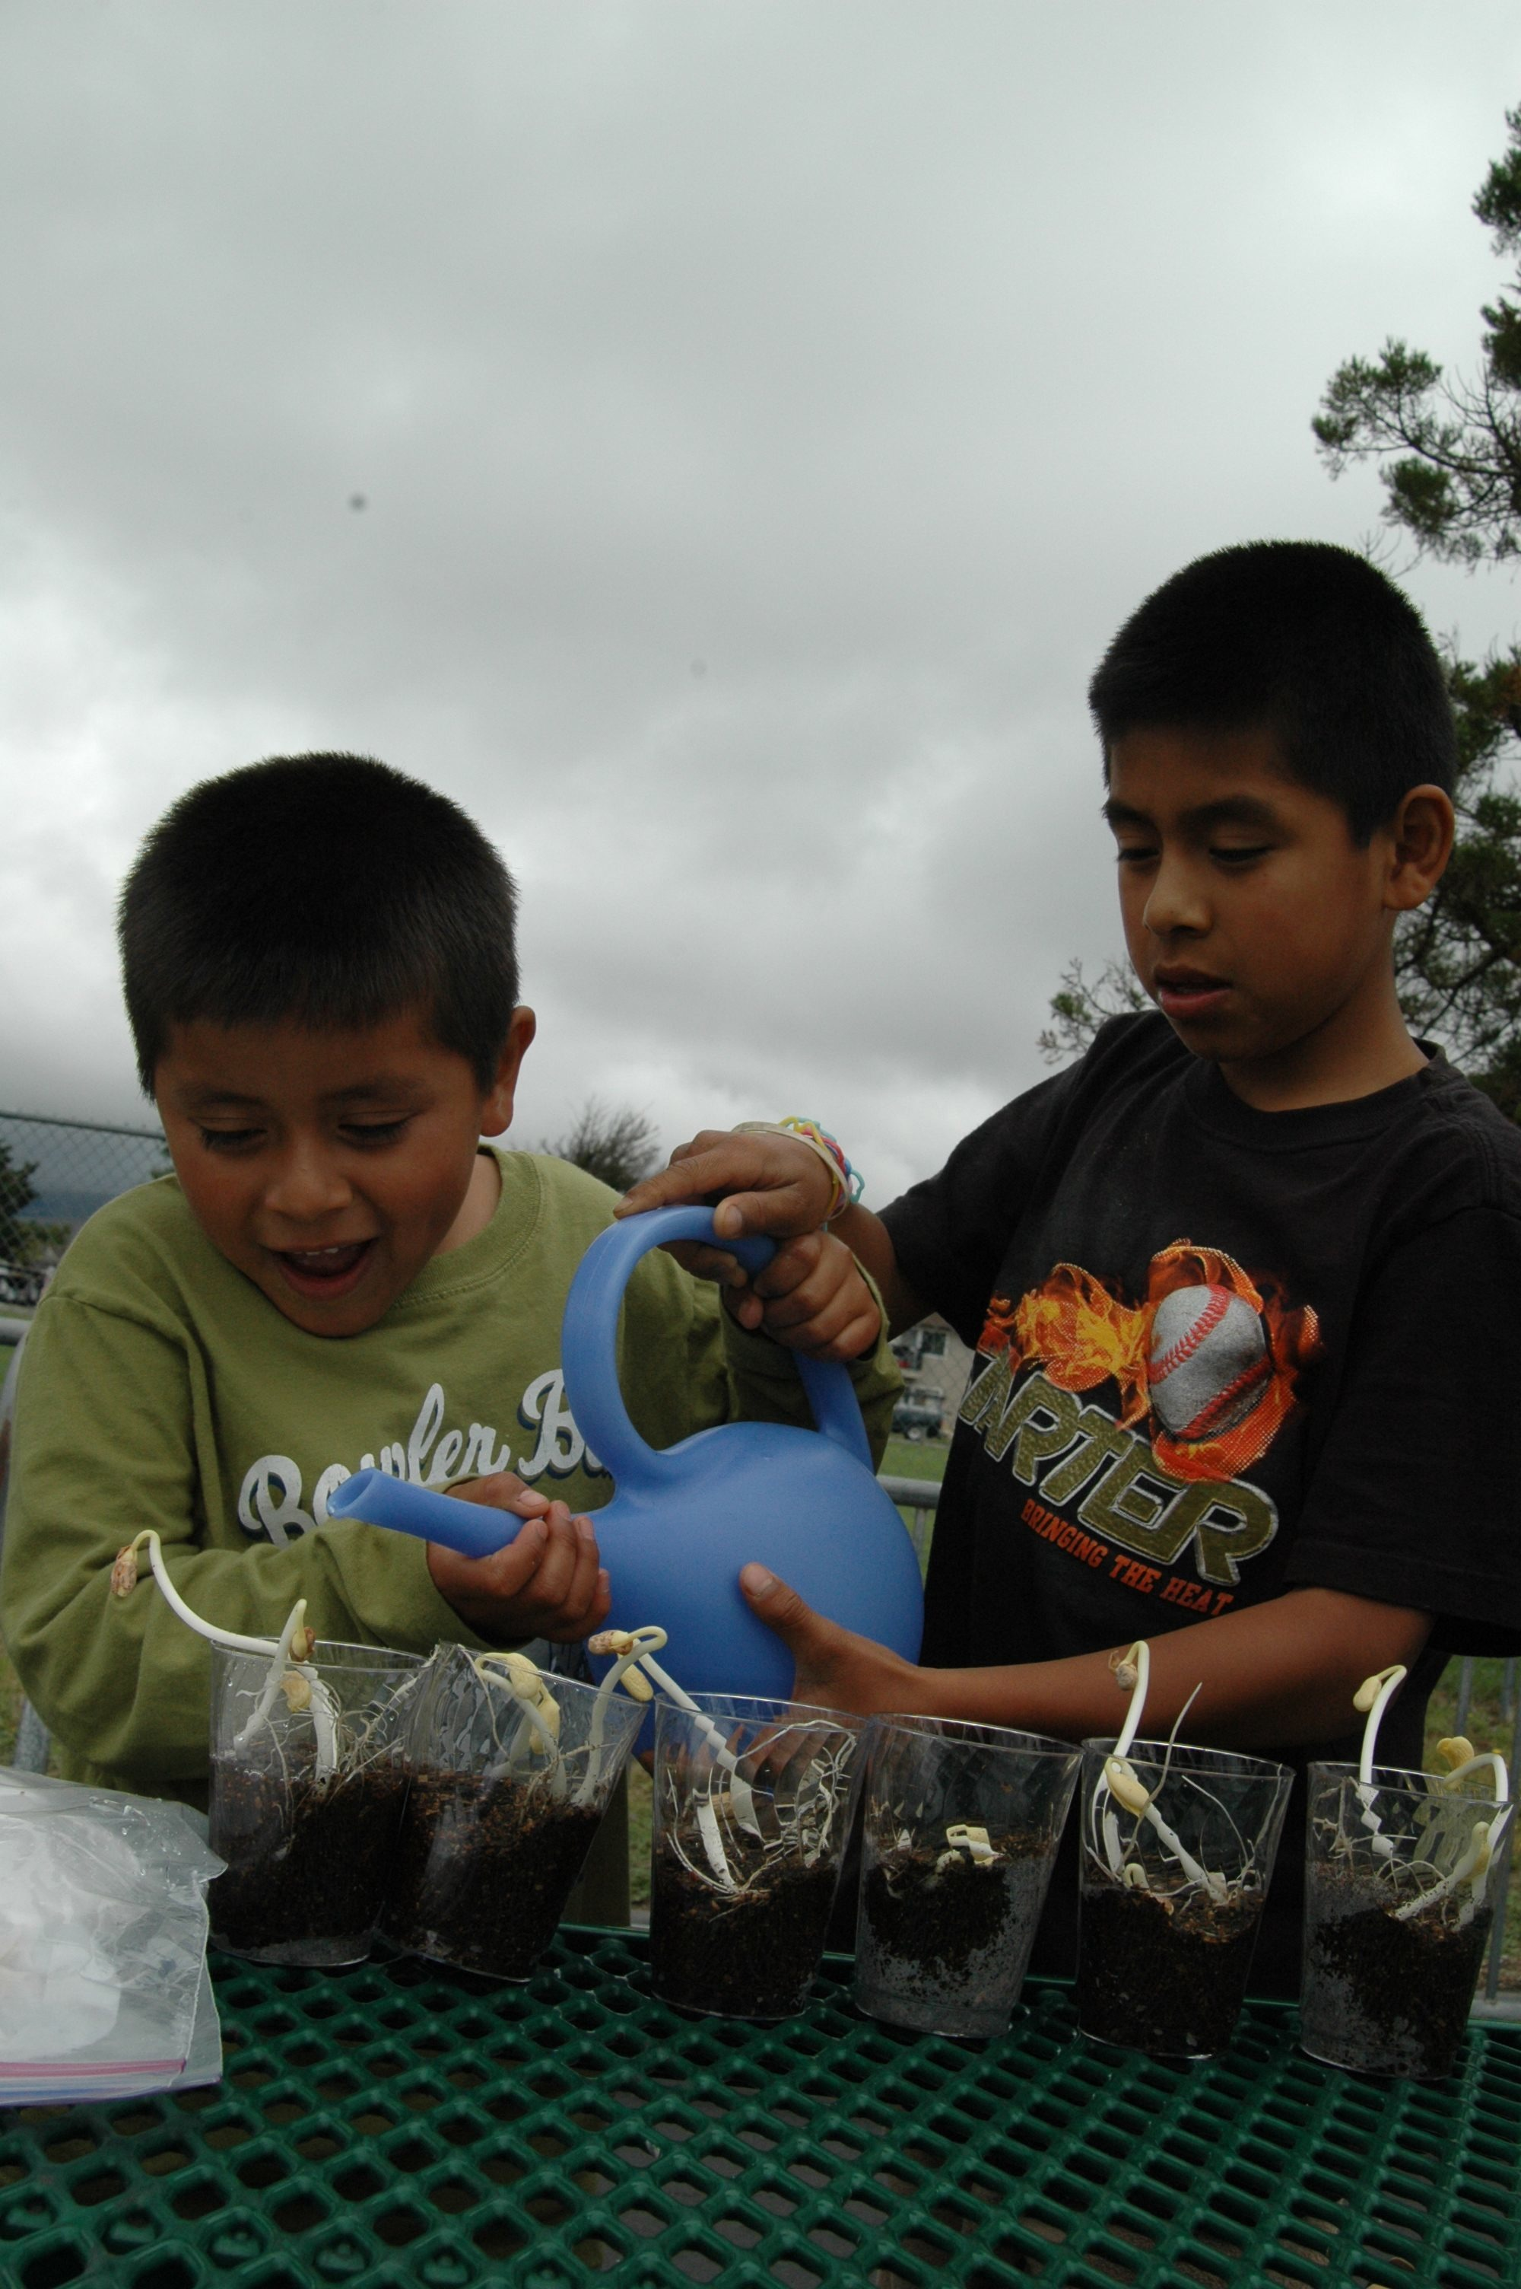
To give its program a physical activity boost, REFB partnered with the Network for a Healthy California’s Children’s Power Play Campaign. Power Play’s Tricia Goldberg worked with REFB’s Program Director Gail Atkins to customize a plan, resulting in 17-18 energetic activities designed to educate the kids about nutrition and physical activity. Anything but sedentary, kids in REFB’s summer meal program were running, jumping, hula hooping, making art, taste testing, flag grabbing, color tagging, and doing the conga.

The 8-week program offered kids novel, challenging activities while providing REFB with an innovative way to engage kids and teach healthy habits. Training for staff and volunteers was minimal at two hours. Consultation and support – as well as materials such as hula hoops, cones and Power Play activity guides, were, as always, provided at no charge by Power Play staff.

“We served approximately 400 kids each week,” says REFB’s Gail Atkins. “Altogether it was an incredible summer. We exceeded 100,000 meals for the first time!”

We salute Redwood Empire Food Bank and its efforts in growing a healthy future for kids in Sonoma County.

