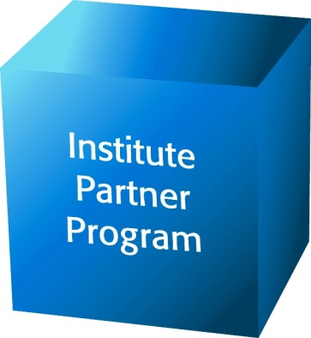


$__________________ Other amount
INSTITUTE PARTNER PROGRAM

Please complete this form and fax to 916-444-7535
For more information contact
Kelly Plag, Director of Communications and Development
at 916-658-8231 or email kplag@ca-ilg.org

Yes! We share the Institute’s commitment to promoting good government at the local level
and want to support the Institute! Here is our information:
Organization
Contact Name & Title
Office Phone
Cell Phone
Address
City, State, Zip
Email
Website
Send payment and this form to:  Institute for Local Government  ATTN: Kelly Plag  1400 K Street, Suite 205  Sacramento, CA 95814  Direct line: (916) 658-8231  Fax credit card sign-ups to:  (916) 444-7535  Thank you for your support! | ____Check _____VISA _____MasterCard for $__________________  Name of Cardholder: ____________________________________________________  Credit Card Number: ____________________________________________________  Expiration Date: ______ / ______ Billing Zip Code ____ ________  Authorized Signature: ___________________________________________________

The Institute for Local Government
Promoting Good Government at the Local Level
501(c)(3) Nonprofit Tax ID 94-1537757
www.ca-ilg.org

