Cities Counties Schools Partnership

Leadership Council Meeting
Friday, April 22, 2016
10:00 a.m. – 2:00 p.m.
League of California Cities
1400 K Street, Third Floor, Sacramento, CA 95814
This meeting is hosted by California State Association of Counties.

Meeting Objectives:
- Network with and learn from fellow leaders and colleagues of statewide associations.
- Explore program and activities for youth-civic education.
- Discuss and direct staff on opportunities related to Stretching Community Dollars.
Page No.

10:00 a.m. | - Welcome and Introductions  - Current Leadership Roster  - August 2015 Meeting Notes | 2  3
10:20 a.m. | - Association Updates, Key Priorities and Activities of Mutual Interest  - League of California Cities  - California State Association of Counties  - California School Boards Association | 3
10:45 a.m. | - Governments Engaging Youth  Presenters:  - Action Civics & Power of Democracy: Dave Gordon, Superintendent, Sacramento County Office of Education  - Summer at City Hall: Councilmember Jay Schenirer  - Governments Engaging Youth: Bina Lefkovitz | 4
12:30 p.m. | Lunch
1:00 p.m. | - ILG’s Partnerships and Collaborations Efforts  - Community Schools Partnerships  - Healthy & Vibrant Communities Project  - Stretching Community Dollars:  - Guidebook  - Opportunities  - Leader-to-Leader Brief  - California Summer Meal Coalition | 6  7  8  8  9  9
1:55 p.m. | - Wrap-Up  - Next Meeting  - Discuss Follow-Up Items | 12
2:00 p.m. | - Adjourn

  - Welcome and Introductions

Welcome to the first CCS Partnership Leadership Council Meeting of 2016.

Current Leadership Roster

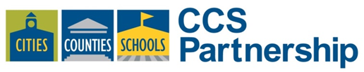
2016 Designations to the CCS Partnership

California State Association of Counties
- Matt Cate, Executive Director
- John Gioia, Supervisor, Contra Costa County, Past President, CSAC
- Don Saylor, Supervisor, Yolo County
- Brad Wagenknecht, Supervisor, Napa County
- Vacancy
California School Boards Association
- Chris Ungar, San Luis Costal Unified School District, CSBA, President
- Susan Henry, Huntington Beach Union High School District, CSBA, President-Elect
- Mike Walsh, Butte County Office of Education, CSBA, Vice President
- Jesus Holguin, Moreno Valley Unified School District, Immediate Past President, CSBA
- Vernon Billy, Executive Director, CSBA
League of California Cities
- Stephany Aguilar, Councilmember, Scotts Valley, Immediate Past President, LCC
- Mike Kasperzak, Councilmember, Mountain View, Board Member, LCC
- Chris McKenzie, Executive Director, LCC
- Dennis Michael, Mayor, City of Rancho Cucamonga, President, LCC
- Greg Pettis, Mayor Pro Tempore, Cathedral City, Board Member, LCC
Members-At-Large (Public Members)
- Davis Campbell, Member-at-Large, Founding Board Member of the CCS Partnership
- Pat Eklund, Member-at-Large, Councilmember, City of Novato
- Alan Fernandes, Member-at-Large, Board Member, Davis Joint Unified School District, Executive Vice President, California State Association of Counties Finance Corporation
Partner Liaisons
- David DeLuz, CSBA
- Farrah McDaid-Ting, CSAC
- Sara Rounds, LCC
August 2015 Meeting Notes
The 2015 meeting of the Cities Counties Schools Partnership provided the leadership an opportunity to learn about and have a discussion on the Local Control Funding Formula. As it was the first meeting since the dissolution of the 501(c)3 status, the leadership also brainstormed focus areas for future discussion and had a discussion about intentional focus for CCS Partnership. Additionally, each association shared updates about policy-making, conference activities and issues of interest to all partners. Full notes are attached at the end of this document. [Attachment 1]

  - Association Updates, Key Priorities and Activities of Mutual Interest

Each association has an opportunity to share updates about policy-making, conference activities and issues of interest to all partners. Updates are provided by a leader or association’s Executive Director.

  - Governments Engaging Youth
Presenters: Dave Gordon, Jay Schenirer, Bina Lefkovitz

A variety of programs engaging youth in government have provided students opportunities to learn about local government, careers in local government and how to advocate for community change. The Institute for Local Government is building a collaborative to support and enhance civic education opportunities among cities, counties, special districts and all local government agencies. ILG is working with its parent organizations and key partners (Sacramento County Office of Education, the Council for a Strong America and the Linked Learning Alliance) to develop a program and increase the positive impact of youth and government engagement in communities throughout California.

Questions to consider:

- What’s happening in your community around civic education and public service career development?

- What communities are ripe for civic-youth education and engagement?

- Where is the greatest need for civic-youth education and engagement?

- What challenges will need to be addressed and overcome for successful partnerships to promote civic-youth education and engagement?

Inspiration for this effort stems from the successful model of government engaging youth through the highly-acclaimed Summer at City Hall program developed at the City of Sacramento and its successor programs emerging at the cities of Elk Grove and West Sacramento. The program models are tailored to meet the needs of the students and based on available staff and financial resources.

In January 2016, the Institute received a $15,000 planning grant from the Stuart Foundation to develop the next steps for a statewide implementation of this youth-civic engagement project. Bina Lefkovitz, Lead Consultant and ILG staff have surveyed cities, counties, special districts and partners as part of an environmental scan.

Today’s presentation provides the CCS Leadership an opportunity to provide direction and advice following an overview of current efforts in California on successful civic youth engagement programs, including a presentation on Summer at City Hall. Leaders are encouraged to discuss the benefits and needs for these programs. Supporting materials are attached to the agenda for your reference [Attachment 2].

Panelist and their Presentation Topics:

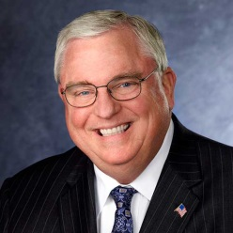
David W. Gordon: Action Civic, Power of Democracy and California’s Civic Education Landscape
David W. Gordon serves as Superintendent of the Sacramento County Office of Education. The Sacramento County Office of Education directly serves more than 30,000 students and provides financial oversight and support services to more than 235,000 students in thirteen school districts. Gordon has previously served as a school superintendent in Elk Grove and was Deputy State Superintendent for the California Department of Education. Mr. Gordon began his career as an elementary school teacher in 1968 in the South Bronx, New York. Mr. Gordon holds a B.A. degree from Brandeis University and an Ed.M. and Certificate of Advanced Study (C.A.S.) in Educational Administration from Harvard University. He has served as an Associate in Education at Harvard University, a visiting scholar at Stanford University, and a visiting professor at the University of California, Riverside. He has served on numerous boards and commissions, including the California Commission on Teacher Credentialing, the California Curriculum Development Commission, WestEd and the UC Davis School of Education Board of Advisors. He has presented at the White House, has been a panelist on the U. S. Department of Education's cable television show, has testified before the U.S. Congress and state legislatures in California and around the nation, and is a frequent speaker at major conferences.

Jay Schenirer: Summer at City Hall, Sacramento Experience
Jay has served on the City Council for 5 years. One key policy interest is in youth leadership development. This led to the creation of Summer at City Hall. He sponsors other efforts to build youth leadership, engage youth in city government, and bring youth perspective to city business. He is the General Manager for Capitol Impact, a statewide educational consulting firm that leads the Linked Learning Alliance to make classroom learning relevant through the creation of career pathways in high schools. His office hosts the Leg Ed project to educate legislative staff around what is happening in local communities around education, health and good governance practices to inform future legislative policies.

- Bina Lefkovitz: Governments Engaging Youth Findings and Next Steps

Ms. Lefkovitz, founder and former Co-Director of the Youth Development Network, currently does consulting around youth civic engagement and youth advocacy. She assisted the city of Sacramento, Elk Grove, Yuba City in creating SACH. Her expertise is in program development, city school partnership development and youth development. She is also a part time faculty member at CSUS and teaches youth development in recreation.

  - ILG’s Collaboration and Partnerships Efforts

Staff requests your feedback:

- Are there examples in your community of leader-to-leader meetings, either informal or formal that can be highlighted in CCS/ILG resources?

- Would you be interested in serving on a panel to talk about partnerships in your community?

Community Schools Partnerships

CCS Partnership continues its three-prong strategy vis-à-vis community school partnerships including the online toolkit, conferences of the three partner associations and the three partner association awards programs. Staff participates in the California Community Schools Network roundtable, presents on quality partnerships as opportunities arise. In summer 2015, the Institute updated its website and the toolkit was moved and updated for the new platform. The former CCS Partnership website and terms navigate to the Institute’s platform seamlessly.
Visit the Community Schools Partnership toolkit
www.ca-ilg.org/community-schools-partnerships

As part of the work with Kaiser Permanente and the Healthy and Vibrant Communities Project (below), staff is engaged in additional case story writings and updating the website with partnerships supporting healthy eating-active living, safety and violence prevention.

When possible, partnerships including schools, cities and/or counties are highlighted in the community schools partnerships toolkit as well. Conference sessions and awards continue to be opportunities to relay best practices on partnerships.
Healthy & Vibrant Communities Project

The Institute’s Healthy and Vibrant Communities project, funded by Kaiser Permanente Northern California Community Benefit (since 2015) aims to increase awareness and provide education about collaboration and partnerships supporting positive outcomes for healthy-eating/active living, safety and violence prevention. The project, ending December 2016 provides the Institute opportunities to share success stories of collaborative efforts to our parent organization’s members via in-person and online educational activities as well as direct assistance. Activities since last November include:

- City Manager’s Conference. In early February, the Institute moderated a session at the League of California Cities City Manager’s Department meeting, “Harness the Power of Partnerships to Achieve your City’s Goals” featuring City Manager Bill Lindsay of Richmond, Julie Rusk, Assistant Director for Community and Cultural Services for Santa Monica and Mercy Santoro with Pasadena Unified School District (formerly City of Pasadena). The session focused on how agencies are using partnerships to effectively and efficiently deliver services and leverage existing human and financial resources. Partnerships featured work that supported healthy eating/active living, safety, violence prevention as well as youth engagement.

- Community Wellness Webinar. In mid-February, staff completed the first of three webinars in the 2016 series focusing on community wellness, healthy eating /active living, safety and violence prevention. Additional webinars are being developed for June 2016 (collaboration for health policy outcomes) and October 2016 (partnerships for gang/violence prevention and youth health and safety).

- Technical Assistance. The Stretching Community Dollars Guidebook is a catalyst for technical assistance in local communities. In early March, Martin and Hang headed to the City of Bishop to facilitate a workshop among leaders with the Eastern Sierra Council of Governments. The Guidebook served as a frame for discussion on the vexing challenges and opportunities for collaboration among local jurisdiction. Conversation and exercises supported the discussion and lead to outcomes for each jurisdiction to complete. The local agencies collaborate out of need to save on limited staff capacity and financial resources; convening the group encourages assessment of activities and outcomes for future collaboration.

Staff continues work on writing case stories, communications and outreach and developing a series of convenings in the central valley and bay area to support local agencies in partnerships for health eating/active living, safety and violence prevention.

- Stretching Community Dollars Guidebook – An update to a CCS Partnership signature document. As part of the work plan for the Kaiser Grant and Healthy & Vibrant Communities Project, the Institute completed an update to a CCS Partnership resource, the Stretching Community Dollars Guidebook. The purpose of the guidebook is to inspire, encourage and support local governments throughout California to achieve purposeful and sustainable intergovernmental collaboration. It incorporates the challenges and opportunities that communities have endured with paradigm shifts such as Realignment, Redevelopment and Local Control Funding Formula. The guidebook clarifies need and processes for collaborations scaling up to systems-change and the advantages of collaboration in two main points:

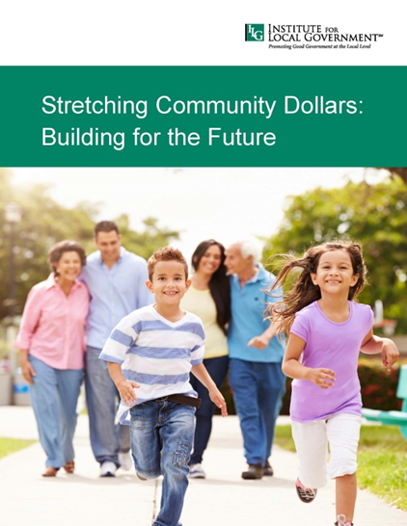
  - More efficient with resources:
Put simply, you can do more with less. By pooling financial and human resources, time and capital, the savings gained can go to other priorities. The cost of operations and services decreases while the quantity and quality of services increases. It decreases duplication and provides opportunities to enhance and expand programming.

  - More effective in the community: The whole is greater than the sum of individual parts. By working together across jurisdictions, local government agencies will increase their reach, power and positive impact in the communities they serve. Collaboration allows agencies to increase their impact.

Stretching Community Dollars is available on the Institute’s website at: www.ca-ilg.org/stretchingcommunitydollars and a copy is attached [Attachment 3].

- Opportunities. The updated Stretching Community Dollars Guidebook was included as a resource for ILG-organized events including a California State Association of Counties Institute course on Intergovernmental Collaboration and the League of California Cities Annual Conference session, “Mayors for Community Wellness.” The Stretching Community Dollars Guidebook was also featured by the California School Boards Association and Public CEO and has been downloaded or viewed more than 230 times from ILG’s website.

- Leader-to-Leader Brief. A companion piece to the Stretching Community Dollars Guidebook is a brief, “Leader-to-Leader: An Opportunity to Share, Understand, Align and Make Lasting Progress.” The document highlights how elected officials and staff may find meeting on a regular basis to identify opportunities for collaboration and leveraging resources is the best way to effectively meet community goals and needs. Joint meetings of the elected officials and/or staff members of city, county, school and/or special district agencies provide an opportunity for local officials to get to know one another, understand organizational missions and functions and to build the trust that allows for stronger working relationships. The Leader-to-Leader Brief is available online at: www.ca-ilg.org/resource/leader-leader-meetings [Attachment 4].

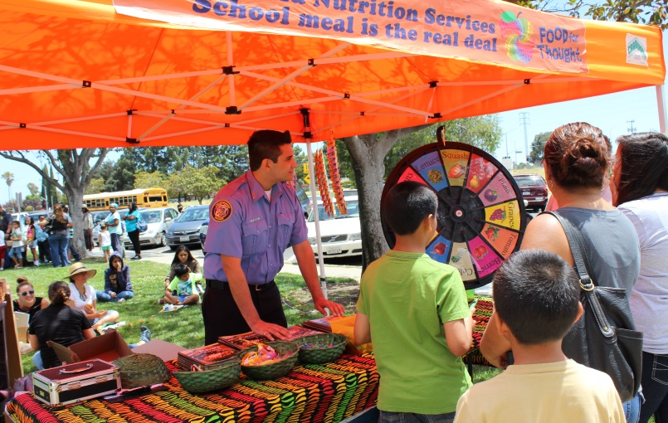
California Summer Meal Coalition

Background: The California Summer Meal Coalition is an ILG initiative to combat food insecurity and childhood obesity by ensuring low-income children and youth have access to healthy food when school is out by increasing access to USDA summer meal programs. The Coalition brings together local and state leaders in child nutrition and physical activity, summer learning, food policy, anti-hunger, youth development, school district leadership, city and county leadership, along with the California Department of Education and the California Department of Public Health. These groups share their expertise to develop and promote strategies that strengthen our communities when school is out. Attached are California Summer Meal Coalition and Lunch at the Library resources [Attachment 5].
Pittsburgh, California: Summer 2015
Summer Meal Coalition Event featuring partners from public safety, local library and community-based organizations.

The year is off to a busy start for the California Summer Meal Coalition, as interest grows in communities across the state to leverage USDA child nutrition programs to build innovative community collaborations that bring together city, county, school, and community partners. The successes of summer 2015 in which the Coalition brought together California’s public libraries, schools, law enforcement, public health and other agencies to create a shared vision for summer has helped communities leverage existing resources and create greater efficiencies while supporting the health and well-being of low-income families (Attached is the 2015 Annual Report). The Coalition’s efforts have helped bring a 10 percent increase in summer meal program participation, drawing down an additional $5 million in federal funds to California communities. As a growing number of cities and counties focus on addressing homelessness, the Coalition will highlight USDA nutrition programs—and the partnerships built around them—to help leaders create efficiencies and strengthen existing community safety nets to support families living in transition and those on the verge of homelessness.

Activities:

- ILG has been invited to participate as part of a national thought leadership group at USDA and is part of a subcommittee with the Federal Transportation Administration and National Recreation and Park Association and other agencies interested in addressing transportation issues in summer. ILG (the California Summer Meal Coalition) is the only state-level organization invited to participate in this effort.

- Hosted a summer meal summit for more than 100 attendees from agencies representing city agencies, school districts, county public health departments, community agencies, healthcare, law enforcement, libraries, tribal governments, and policy advocates. Leaders from USDA, California Department of Education, California Department of Public Health and California Department of Food and Agriculture participated. Presentations from UCSF, Stanford, San Bernardino Public Health, City of Riverside, San Mateo County Library, City of San Francisco, Hayward USD, San Ysidro USD and USDA's Farm to Fork Office promoted a range of promising practices to support healthy community partnerships. The event was well received, with 97 percent of evaluations ranking the event as good or excellent. As a result of the summit, USDA Administrator Audrey Rowe shared the successes in Contra Costa County (a project of the Summer Meal Coalition) at the White House with leaders from the US Conference of Mayors as a best practice.

- Hosted a workshop at the Ontario Library for more than 30 city, county and special district librarians from around the state to facilitate the expansion of Lunch at the Library to more libraries and promote partnership opportunities with other agencies.

- Presented on two webinars: California Department of Public Health's mandatory webinar for funded local health departments and California Department of Social Services Food Access committee (FANOUT) for local and state leaders in social services, public health.

- Presented at two conferences: Washington DC-based Food Research and Action Center/Feeding America's national anti-hunger policy conference and regional convening hosted by the United Way California Capital [sic] Region.

- Provided technical assistance to seven communities to advance Lunch at the Library. As a result, secured partnership between Martinez USD and Contra Costa County Public Library; Working on partnership between Richmond City Library and West Contra Costa USD; and developing partnership between Tuolumne County Public Library and County Public Health Department. Provided technical assistance to 3 city councils.

- Lunch at the Library will be featured as a promising practice in a guide jointly published by The White House and National Summer Learning Association, designed to help cities and schools identify opportunities and resources to support children and youth when school is out.

The Coalition’s key areas of focus for 2016 include:

- Expansion of Lunch at the Library. With support from the David and Lucile Packard Foundation, the Coalition will continue to expand city- and county-wide collaborations through its partnership with the California Library Association to expand public libraries as summer meal sites. In addition to addressing hunger, these partnerships also address the need to improve literacy skills among low-income youth, a key variable in connection to crime, health and economic vitality of a community. State Librarian Greg Lucas and other elected officials will help us kick-off summer at the Ontario Public Library in partnership with the school district. The event will highlight how city agencies in Ontario will “adopt a week” over the course of the summer. Additional kick-off events will be held at the Fresno County Public Library, San Jose Public Library and other libraries that will include elected city and county officials and highlight tangible examples of community partnership.

- Build countywide-models of collaboration. Through a countywide partnership with Contra Costa County school districts, food bank and other key partners, the Coalition will provide support to expand community partnerships and through summer meal programs. This effort will help provide a “roadmap” for leaders in other communities, highlighting the opportunities for elected leaders, city and county agencies, schools and special districts to address the critical issues facing the wellbeing of families in the community. This effort will include a special focus on engaging special districts because of the strong partners in the county.

- Support the health of families in drought-impacted communities in the Central Valley. With support from The California Endowment, the Coalition will continue its work in the Central Valley to leverage USDA summer and other child nutrition programs to offset the “human impact” of the drought. These programs provide an opportunity to draw down millions in federal dollars and create city and county efficiencies. Efforts will focus on city and county-level collaborations within Kern, Tulare and Fresno counties. One area of focus will be through joint city council-school district collaborations and convenings; another area will include exploration of connection to larger community planning and transportation needs and goals.

- Technical Assistance. Continue to provide technical assistance to cities, counties, schools, special districts to use USDA child nutrition programs to build tangible, trusting, and sustainable partnerships that address critical community issues.

  - Wrap-Up

Leadership Council Meetings for 2016

The Institute will work with staff at the California School Boards Association, California State Association of Counties and the League of California Cities for a meeting date in October 2016 to be hosted by the California School Boards Association.

Follow-Up Actions

Leaders and staff will confirm follow-up actions to ensure accountability of the Leadership Council’s efforts.

  - Adjourn

Attachments:
- Attachment 1: Leadership Meeting Summary August 2015
- Attachment 2: Governments Engaging Youth Information Overview
- Attachment 3: Stretching Community Dollars Guidebook
- Attachment 4: Leader-to-Leader Brief
- Attachment 5: California Summer Meal Coalition Materials

