[Cover]

Yuba City
Summer at City Hall

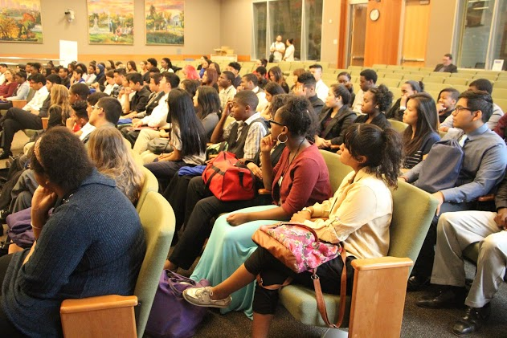

Job Shadow
Brochure
2016

[inside, backside right flap]

Summer at City Hall 2016

Thank you for volunteering to serve as a job shadow professional for the inaugural year of Summer at City Hall! We are all in on the ground floor of what is to become a strong partnership between the City of Yuba City, Yuba City Unified School District (YCUSD), and the various participating agencies. Much planning has gone into making this experience highly beneficial and rewarding for our students and for you. Each of the students participating in the program attends one of three high schools (list names), and will either be a junior or senior when school starts this fall. Each of the students have demonstrated a sense of commitment and desire to gain relevant experience by voluntarily giving up two weeks from their summer vacation to participate in our program.

We have done our best to match student interest with job shadow agencies. We think that you will be impressed with their level of maturity and eagerness to learn about your agency. Below you will see a typical job shadow schedule for the program. We realize that certain agencies will need to modify this schedule, and we look forward to supporting your needs.

Sincerely,
SIGNATURE

Lauren Ewert, Summer at City Hall Instructor
SIGNATURE

Darin Gayle, Deputy City Manager

SACH 2016 Job Shadow Schedule
June 15th & June 17th, 2016
9:00AM-Noon

- Meet & Greet at City Hall
June 14th, 2016, 1:00PM-2:00PM

[First flap/backside of front page]

WHAT IS JOB SHADOWING?
Job shadowing is a popular work-based learning activity that provides a student the opportunity to learn on-the-job skills and career information related to jobs with Yuba City and partner agencies. Job shadows involve student visits to a variety of work places during which time students observe and ask questions of individual workers.

GOALS OF THE SHADOWING PROGRAM
- Demonstrate the connections between academics and careers.
- Build community partnerships between schools and government.
- Introduce students to the requirements of city careers and skills needed to do various city jobs
- Creates intergenerational connections between young people and caring adults.
- Helps student learn about function and roles of city departments and how the public is served.

BENEFITS OF THE JOB SHADOWING PROGRAM
- Student Benefits: Provides an up-close look at workplaces and careers I Demonstrates the link between education and future success I Helps youth decide what careers may or may not be of interest

- Workplace Benefits: Showcases your place of work by increasing visibility in your community I Prepares our future work force I Informs students about careers in your industry or line of work

- City Staff Benefits: Become a positive adult role model I Showcases your skills, knowledge, educational and career life experiences I Impact a young person's life in a meaningful way

- Teacher Benefits: Invites teachers to learn firsthand about government and government careers and how to then apply that learning to what is taught in the classroom I Provides up-to-date job examples to share with students I

[Middle section of the trifold]

HOW DOES IT WORK?
Job Shadows are a natural partnership between the classroom and the workplace. Before the visit, students participate in activities that prepare them for the visit. During the experience, workplace hosts should conduct activities with students that demonstrate/teach job skills, educational requirements, personal career journey of staff, career ladders and expose students to what the agency does as a public entity, including current issues facing the agency and how the agency impacts the community to make Yuba City a great place to live. After the site visit, the students participate in post activities to reinforce and share what they learned.

- The Work Site Host: Introduces students to the positive aspects of work I Prepares for the student site visit I Hosts the student during the visit I Helps students understand skills needed for the job and other careers in the agency, explains what it is like to work for government and shares personal stories about their own career journey.

- The Student: Demonstrates desire to explore career options, personal skills, attributes I Willing to develop a personal action plan to improve education and skills I Participates in preparatory activities conducted by the school I Follows all safety and security policies and procedures of the employer I Actively participates in activities structured by the Work Site Host.

- The Teacher or School Coordinator: Identifies interested students I Helps match students with job shadow placements based on student special needs, interests and courses of study I Teaches students a selection of pre- post-job site activities I Collects Parent/Guardian Consent Form and Medical Authorization I Arranges student's transportation to work site I Supervisors job shadow placement.

[Last trifold (right side)]

PREPARING FOR THE JOB SHADOW

Your Experience: Help your student understand your job, the work place skills you use to perform your job, and how a person can obtain this type of position. Consider these questions:
- What is your job title? What are your responsibilities?
- What is a typical day like for you? What do you like the most about your job? Why? What do you the least about your job? Why? Why did you select this type of work?

- How much education do you need for this job? Did you need additional training? What skills are needed for this job?
- What did you learn in school that helps you most on the job? What do you wish you had studied more of when you were in school?
- What does your agency do? What is the budget? What types of careers are offered in this agency? How does your agency make life better for people in Yuba City? What are key issues facing your agency?

Activities: Having students observe different activities and workplace jobs to gain valuable workforce knowledge. Consider the following:

- Computer/Office skills: Word processing I Spreadsheets I Email I Graphic software
- Client/customer contact: Observe client/customer relations, phones inquires
- Meeting skills: Scheduling I Observe brief meetings
- Presentation skills: Observe and provide feedback on presentations
- Social Media: Review/feedback on agency web site, facebook/twitter, flyers, publications
- Processes: review different city processes-city council agenda development, speed bump request/ animal control complaint processed
- Interviews: Students interview you and other staff to learn about careers and your department

[Insert]

DAY OF JOB SHADOWING EXAMPLE
As the Work Site Host, you will have two three-hour sessions with your student. Below is an example of what a typical day of job shadowing might look like.

- Greet your student: Your student should be greeted as an adult business associate, with a handshake and a warm hello. Provide your name, job title and business card. Let your student know how important you think job shadows are to help students see firsthand the application of what they are learning in school. Encourage them to ask questions during the time you have together.
- Get to know your student: Students are most relaxed when they are talking about something they know and aren't being "tested" by an adult. Talk to your student about their interests and hobbies. Ask about their career goals and extra-curricular activities.
- Student Interview: To provide more insight about your job, suggest that your student conduct an interview with you. Help them link what he/she is learning in school to what you do on the job.
- Tour of your office: Introduce your student to fellow staff and give them an overview of your agency’s mission, goals, functions and key issues. Illustrate what a typical day looks like in your shoes.
- Job Duties: Teach your student about your specific job duties and skills. Have them practice a specific duty. This can include crafting emails, reading documents, reviewing data, attending meetings.

[Back cover]
Summer at City Hall (SACH) is a partnership of YCUSD, Yuba City and Sutter County Office of Education (Career Pathway Trust grant).
Vision: The City, the schools and other community adults support all students in becoming active citizens who vote, volunteer, lead, give back and are committed to improving their communities.

Goal: The city and school district partner to help students gain 21st century skills, learn about careers in local government, increase their interest in and provide opportunities for students to become civic minded, and increase youth voice in real city issues.

Objectives:
- Students learn about how local government operates
- Students understand what active citizenship means
- Student learn 21st century and civic skills
- Students become involved in making their community better
- Students register to vote, volunteer their time and step up to be leaders
- Students learn how to advocate for themselves and others
- Students explore and experience careers in city government, gain work experience and reflect on how this program impacts their course and college choices
SACH is part of the Institute for Local Government’s Governments Engaging Youth Initiative. There are currently five cities in California who are implementing various forms of SACH.
www.ca-ilg.org/GovernmentsEngagingYouth

